Email #1: CEO Email to Organization
Email #2: Ambassador email to the organization
Email #4: Supporting People in Crisis
Email #5: Building Prosperity
Email #6: Thank you

Note that custom banner images and optional additional photos are linked at the top of each email.

Some emails contain hyperlinks to videos that may be embedded if your email program allows.
Email #1: CEO Email to Organization
From: [CEO of Organization] [ email ]
Subject Line: Let’s create LA’s future together!
Pre-header: Here’s how you can make an impact today

[DOWNLOAD BANNER IMAGE]
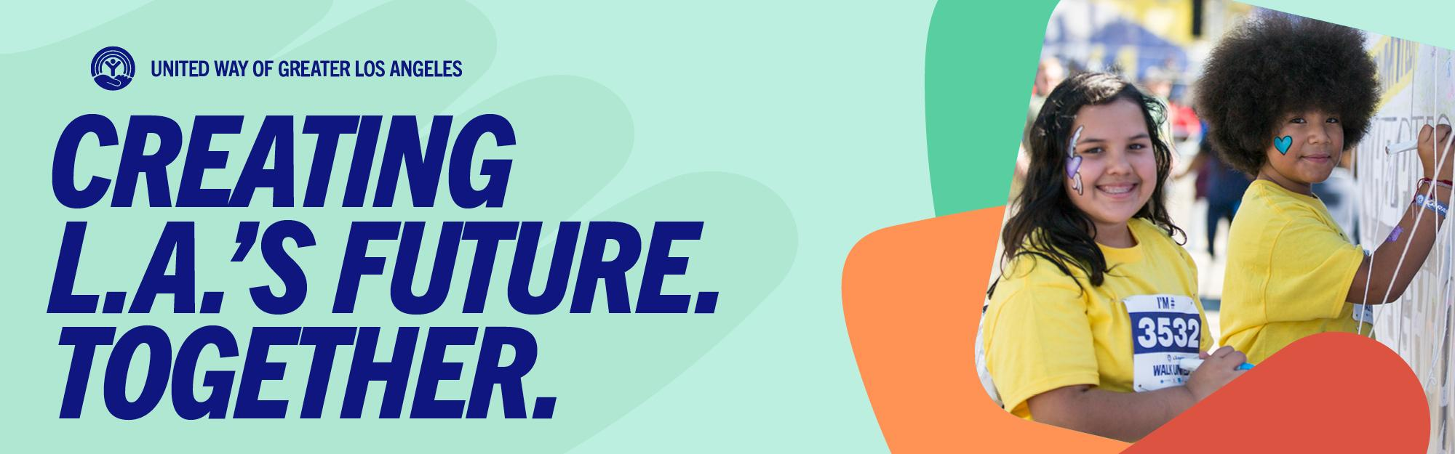
Dear [Organization] Team,

[Organization name] is proud to partner with United Way of Greater Los Angeles to support our community through this year’s workplace campaign.

Over the next several months, we will be offering opportunities for you to donate, volunteer, and learn more about how you can participate in United Way of Greater L.A.’s mission of helping people build generational prosperity and racial equity so that everyone is supported in crisis and every community can own a share of L.A.’s future.

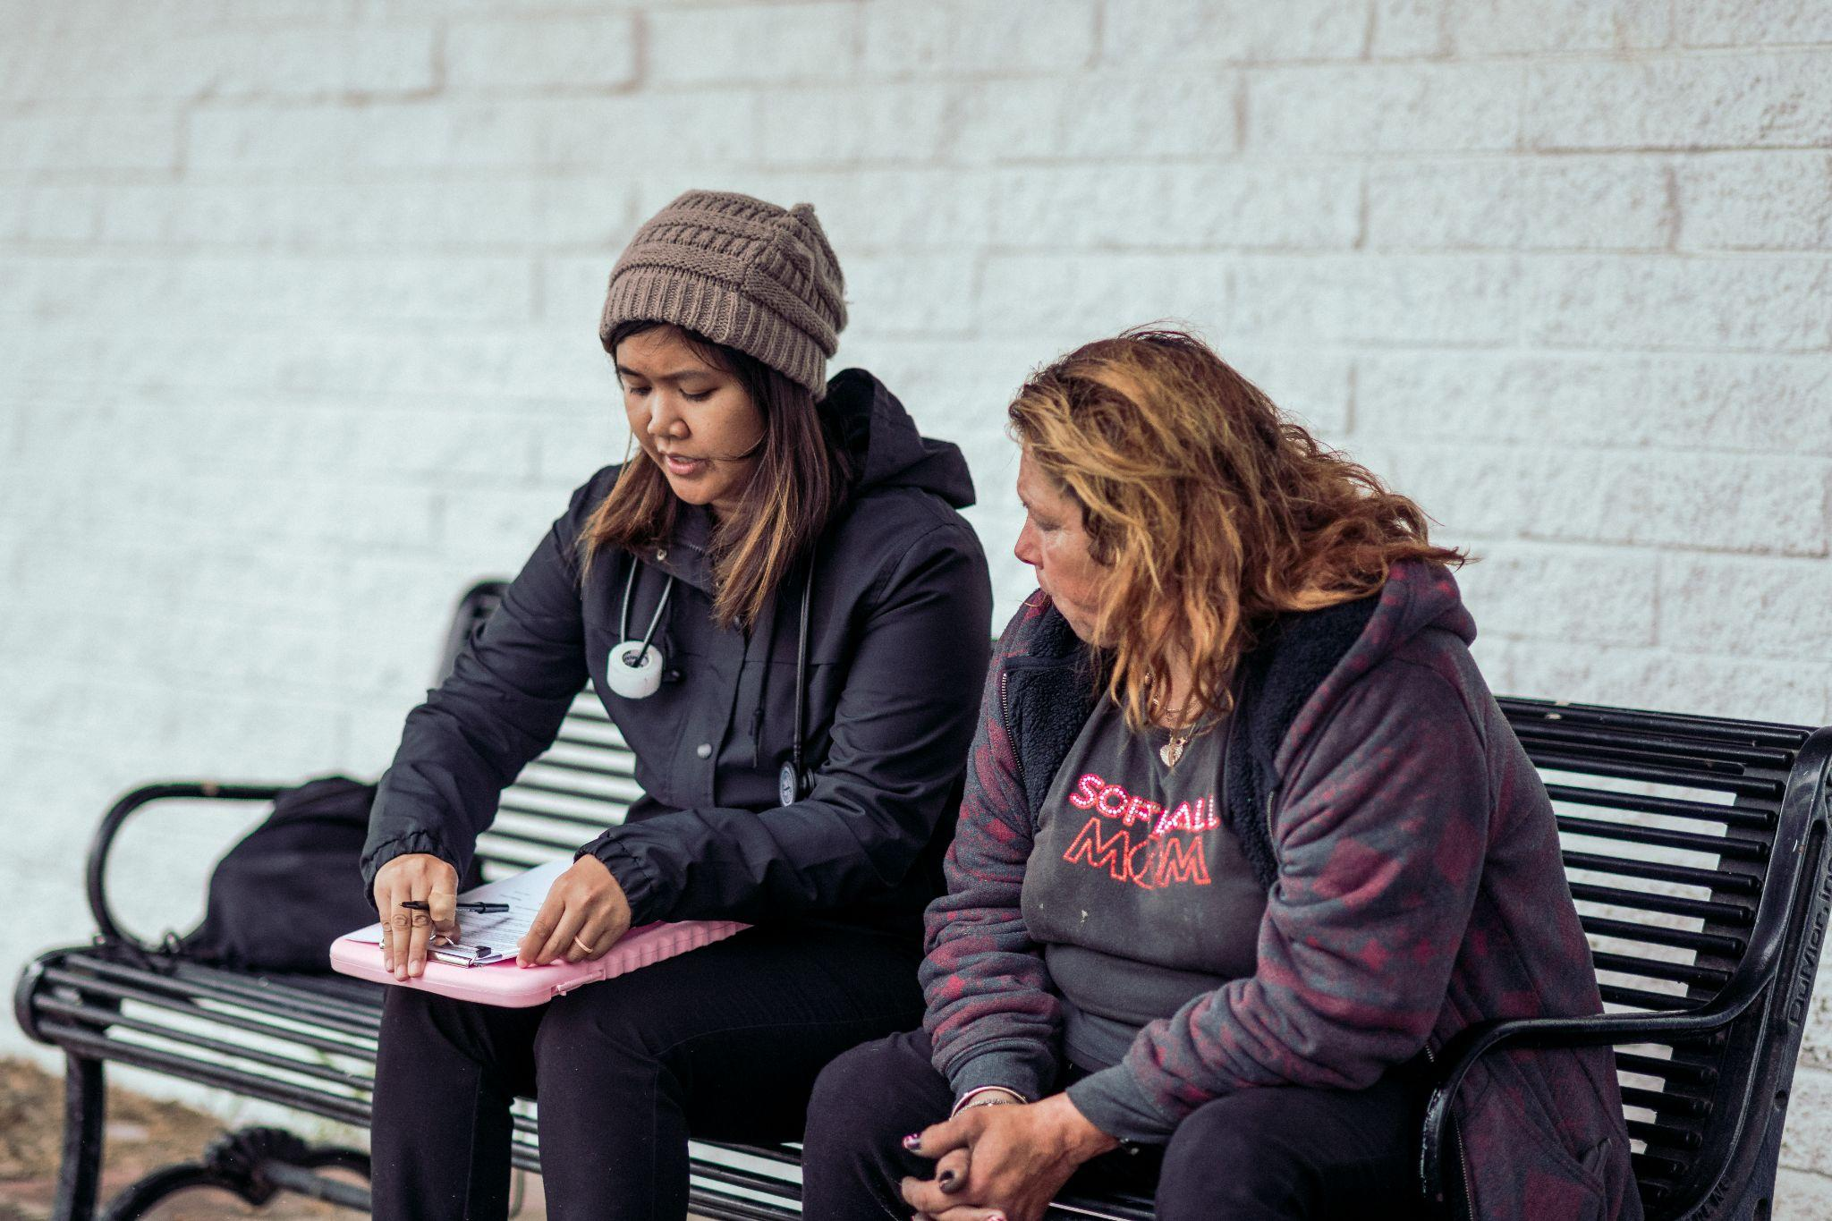
On [campaign kick-off date], [Organization] will participate in [insert first campaign engagement series].

United Way of Greater L.A. is one of LA's most trusted nonprofits, mobilizing neighbors and investments to support each other in a crisis and build a future where everyone shares in our region’s wealth and prosperity.

[Name of Workplace Ambassador(s)], our Ambassador [s] for this giving campaign, will be providing you with the information you need to participate. You can reach out to [him/her/them] at [email] with any questions you may have.

Your generosity throughout the workplace campaign will help United Way of Greater L.A. continue to embrace innovative strategies to end homelessness, create more affordable housing, and support families of color to build generational wealth for their communities across our region. I hope you will consider joining!

Sincerely,
[Name and Signature]
[ORGANIZATION FOOTER]


unitedwayla.org | Find us on: Facebook | Twitter | Instagram | YouTube
Email #2: Ambassador email to organization
From: Workplace Ambassador [ email ]
Subject Line: Join [Organization] and United Way of Greater Los Angeles in creating L.A’s future!
Pre-header: Here’s how you can build a more equitable future

[DOWNLOAD BANNER IMAGE]
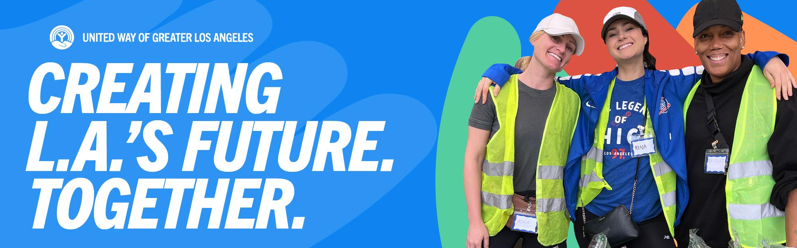
Dear [Organization] team,

Our giving campaign for United Way of Greater Los Angeles has officially begun!

For over 100 years, United Way of Greater L.A. has been one of LA's most trusted nonprofits, mobilizing neighbors and investments to support each other in a crisis and build a future where everyone shares in our region’s wealth and prosperity.

WATCH THE VIDEO

When we give to United Way, all of our donations support their mission of helping our most vulnerable neighbors. And because [Organization] will be matching [ x% ] of every employee contribution, your gift will go even further for our community. I am proud to lead as your Campaign Ambassador and am here to answer any questions you may have about how to participate in our campaign.
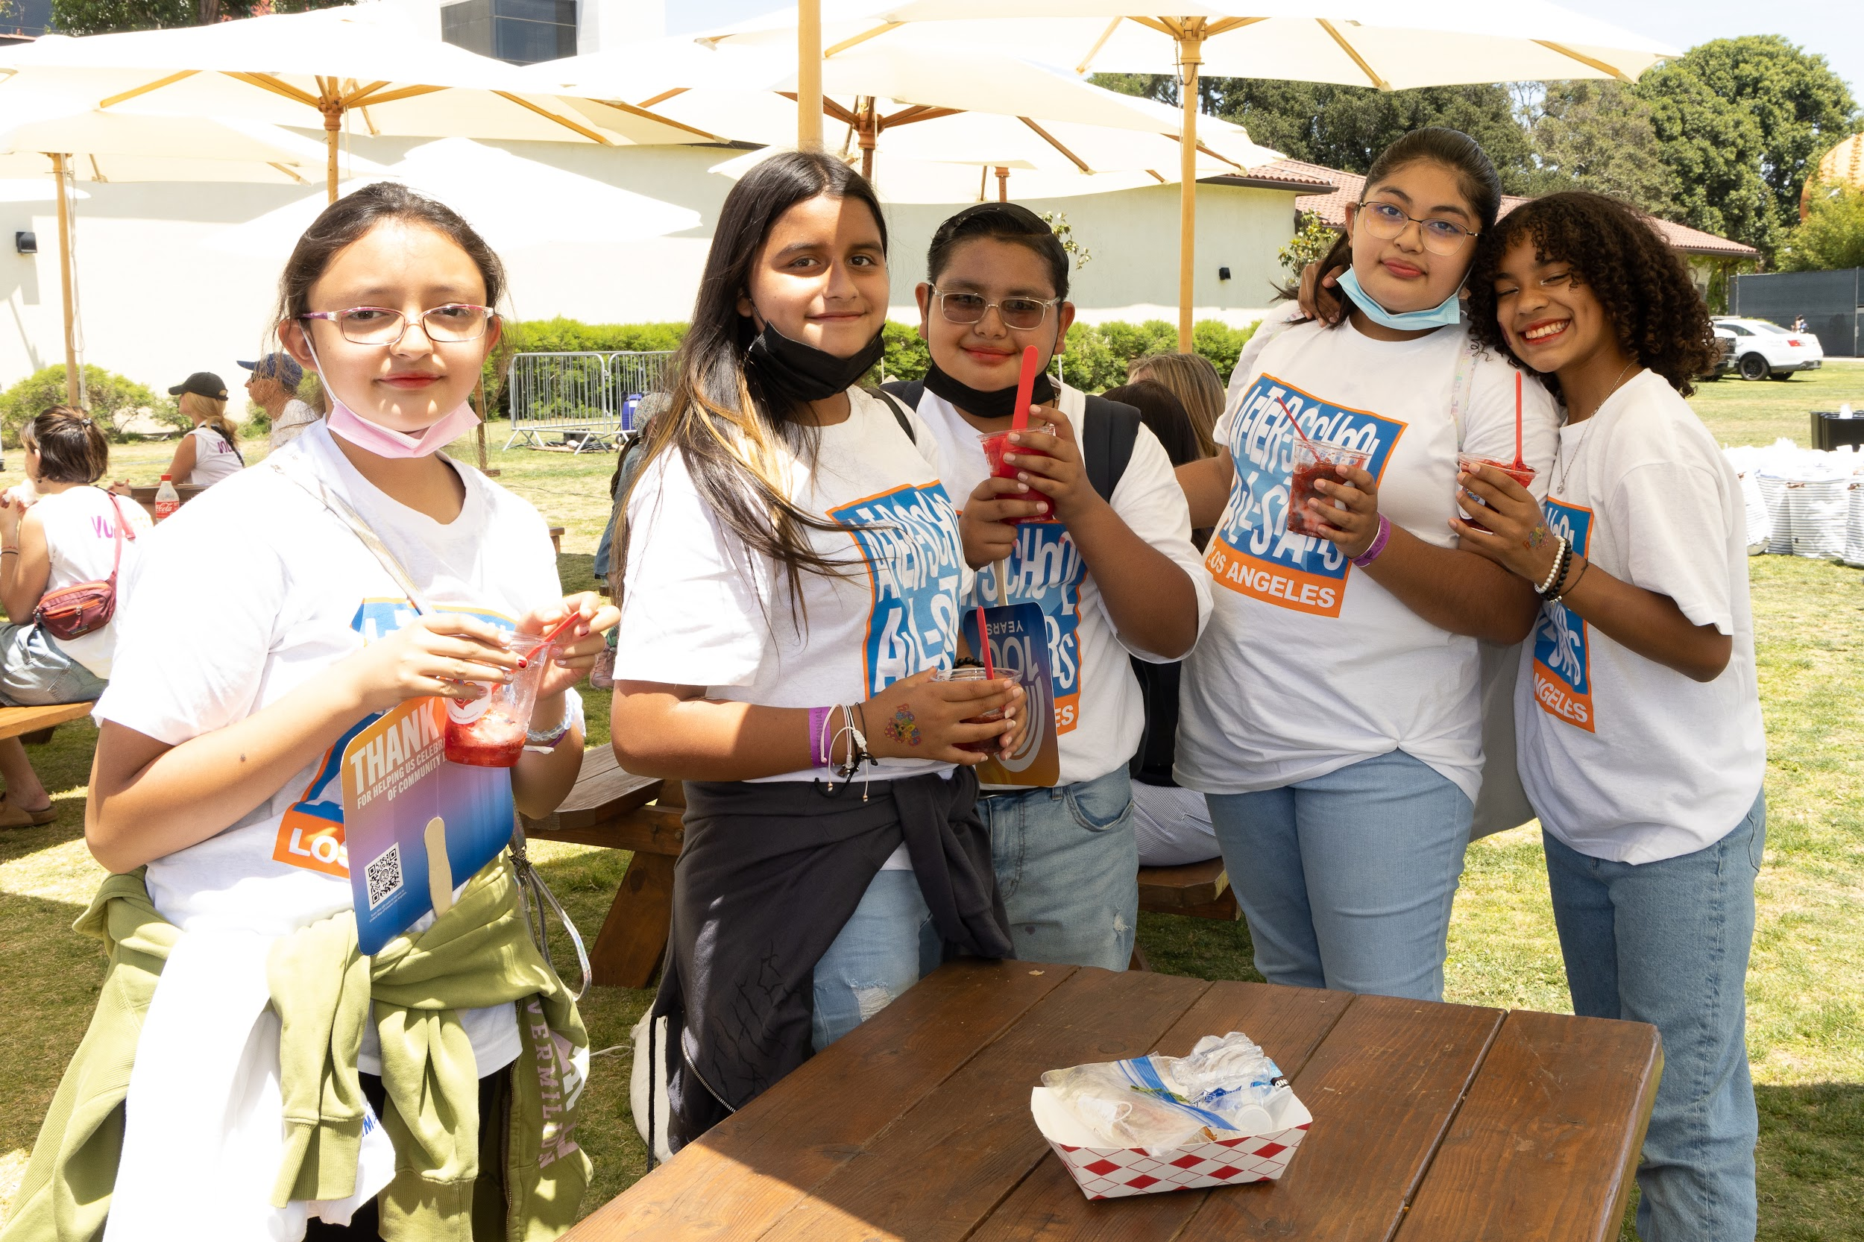
You can begin contributing to United Way today through payroll deduction. If you’d like to make a recurring contribution to United Way of Greater Los Angeles, you can set up an auto-deduction from your paycheck here: [insert giving portal url here].

We will also be participating in United Way’s annual WalkUnited Event in May to ensure housing, education, and opportunity for all. I invite you to join [Organization’s] team by reaching out to me to learn more about next year’s event and sign up.

[Insert further specific events of Organization’s] workplace campaign here: kickoff events, [volunteer opportunities]

Thank you for standing with us as we support United Way’s efforts to prevent homelessness, support students for college completion and career success, and help families build generational wealth and community prosperity across L.A. County.

Sincerely,

[Name and Signature]
[ORGANIZATION FOOTER]

unitedwayla.org | Find us on: Facebook | Twitter | Instagram | YouTube

Email #4: Supporting People in Crisis

From: [Workplace Ambassador] [email]
Subject Line: You can make a life-changing impact on people’s lives
Pre-header: Together we can prevent and end homelessness in L.A.

[DOWNLOAD BANNER IMAGE]
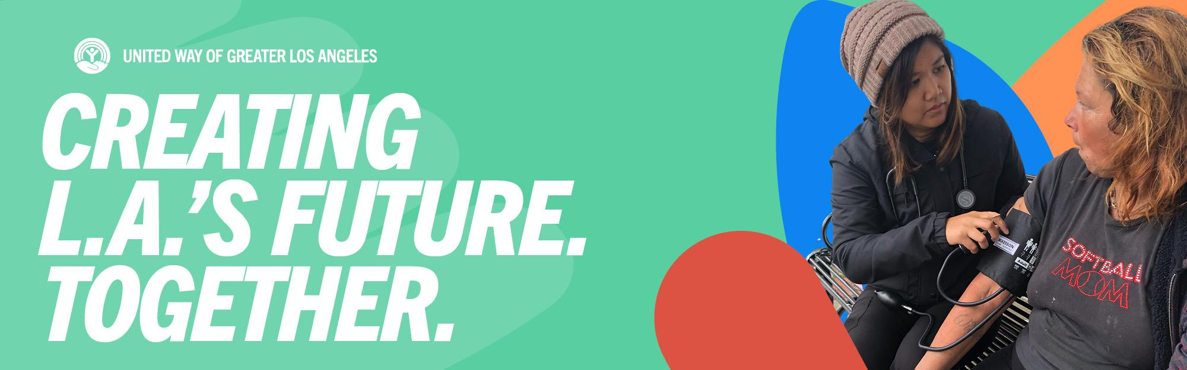
Dear [ORGANIZATION] team,

The 2023 L.A. County Homeless Count report showed that more people are now without homes. This includes young people who were in foster care and older adults. There are now at least 75,518 people of all ages who will sleep tonight in places like shelters, cars, under bridges, or on the street. This is a 9% increase in homelessness in the county. Many people are close to becoming homeless, and your help can prevent this from happening.
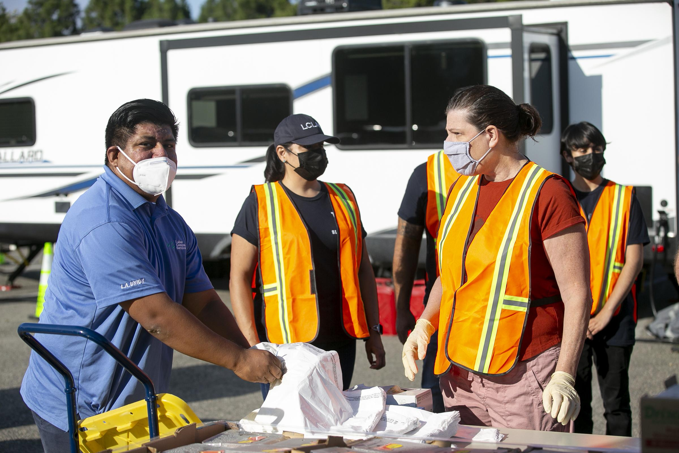
For the past 40 years, United Way of Greater Los Angeles has led the EFSP local board in awarding over $200 million in federal EFSP funds to provide critical emergency support to local community partners helping with rent/mortgage, shelter, and food assistance to families and individuals in need.

Since 1982, UWGLA has partnered with Southern California Edison and SoCalGas® to provide vital utility assistance to people facing financial hardship. The Gas Assistance Fund has provided bill payment assistance of $18 million to more than 224,000 individuals, families, seniors, and veterans.

Join [ORGANIZATION] in supporting United Way to continue helping people facing housing and food insecurity. You can make a life-changing impact on many people’s lives!

This is what your dollars can do:

One-time or monthly donation | Impact
$5- $120 | Invest in food security for 10 families struggling with rising household costs.  Support a community member with lived experience of homelessness in advocating for a stronger LA.
$10- $240 | Keep the power on for one low-income household for one month, through utilities assistance.  Provide a safe shelter space to stay at night for 4 unhoused individuals
$25- $600 | Celebrate and support homeless service workers providing care and housing services to our unhoused neighbors.
$50- $1,200 | Assist a community college student in weathering financial emergencies that allow them to stay in classes.
$250- $6,000 | Support neighborhood hub partners in hosting a community care event that supports residents in need.  Contribute to improved spaces serving unhoused and senior households seeking support.

MAKE A DONATION TODAY! [hyperlink to giving portal]

Sincerely, [Name and Signature]
[ORGANIZATION FOOTER]

unitedwayla.org | Find us on: Facebook | Twitter | Instagram | YouTube

Email #5: Building Shared Prosperity

From: [Workplace Ambassador] [ email ]
Subject Line: Imagine an L.A. where everyone can thrive
Pre-header: Help your neighbors find stability and prosperity

[DOWNLOAD BANNER IMAGE]

Dear [ORGANIZATION] team,

We’ve made great strides in our giving campaign to date. Let’s keep up the momentum!

Today, nearly 1.5 million Angelenos live below the poverty line, and centuries of institutional and systemic racism have perpetuated disparities and generational poverty in communities of color across our region. The economic mobility work that United Way is doing is critical to not only help families stabilize financially but to create opportunities to build wealth.

United Way believes in the power of people coming together to create prosperity in their own communities, where every person have access to Housing, Opportunity, Prosperity and Equity (HOPE) in neighborhoods across Los Angeles County. Some UWGLA initiatives building prosperity across the region are:

- The Affordable Housing Initiative is financing 580+ units for housing-insecure neighbors all across the county.
- The Women’s Investment Network is helping 200 Black and Latina women build wealth and invest in their communities.
- The Volunteer Income Tax Assistance ensures low-income families maximize returns, claiming $4.2 million in federal returns for 1,520 households this year alone. Low-income families claim an estimated $4.2M in federal returns and $799,500 in state returns – assisting an estimated 1,520 households through VITA
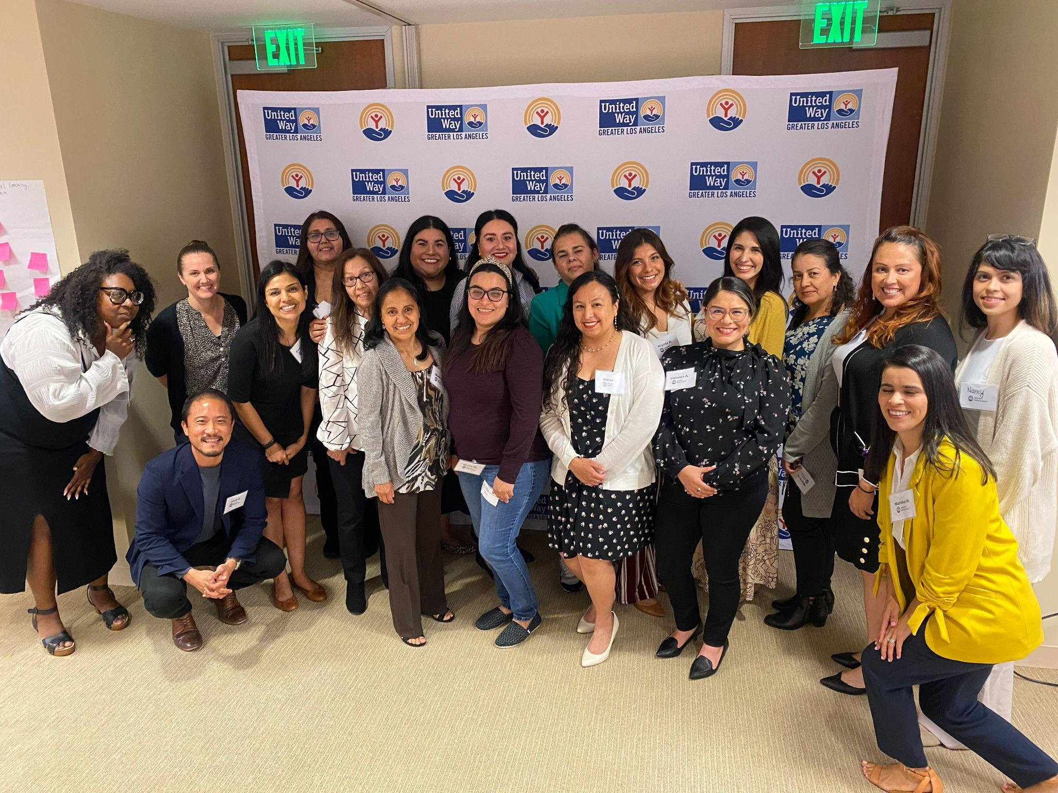
Let’s help United Way to create shared prosperity in L.A. by supporting their HOPE initiative.

Your workplace campaign contribution also makes you eligible to join the L.A. Giving Community– our way of appreciating your support by offering members the chance to come together to enjoy exclusive events, discounts and more.

MAKE A DONATION TODAY. [hyperlink to giving portal]
Sincerely, [Name and Signature]
[ORGANIZATION FOOTER]

unitedwayla.org | Find us on: Facebook | Twitter | Instagram | YouTube

Email #8: Thank you

From: [Workplace Ambassador] [ email ]
Subject Line: We did it, you made it possible!
Pre-header: Thank you for helping United Way and [ORGANIZATION] create L.A.’s future!

[DOWNLOAD BANNER IMAGE]
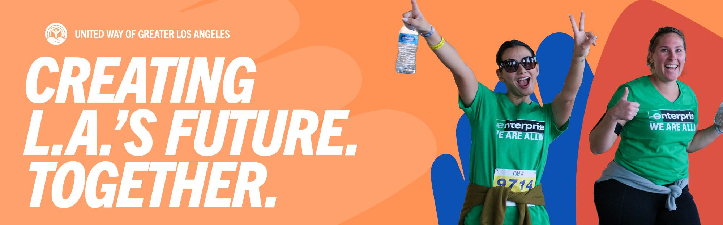

Dear [ORGANIZATION] employees,

Our giving campaign was a success. On behalf of [ORGANIZATION] and United Way of Greater Los Angeles, thank you for your generous contributions. Together we raised [$$$]!

Today, we are helping people build a new future of prosperity and racial equity so that everyone is supported in crisis and every community can own a share of L.A.’s future.
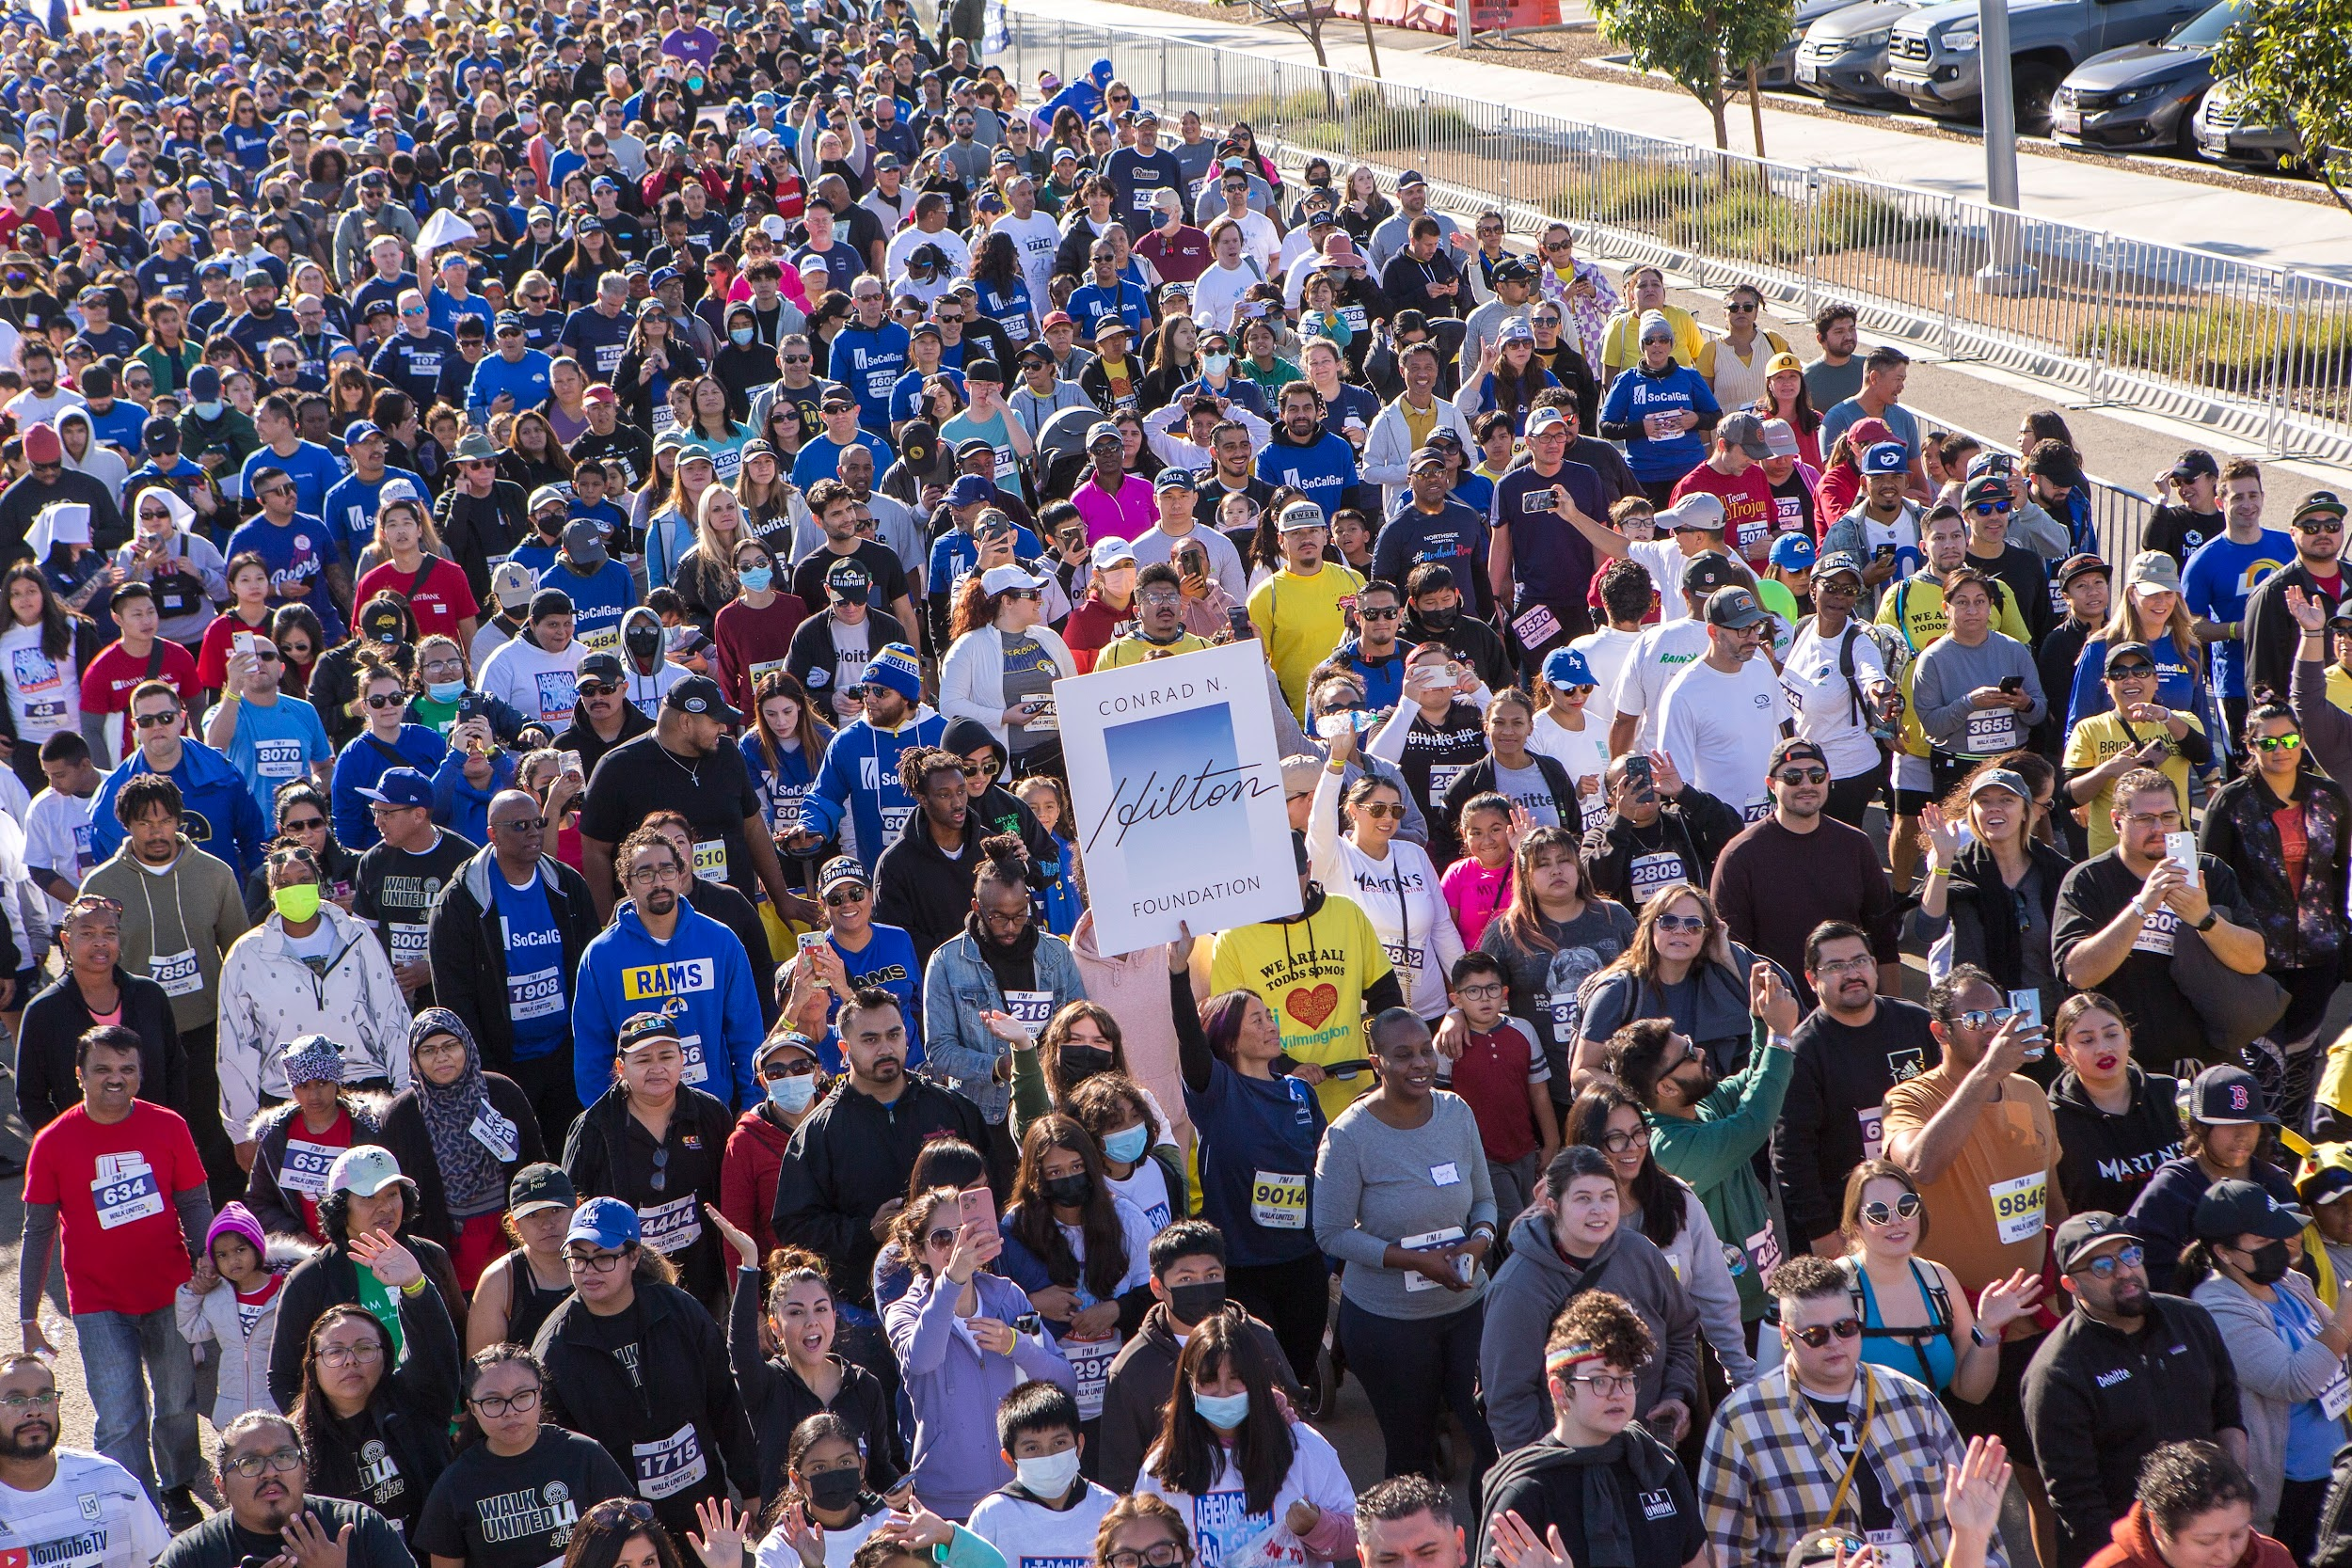
If you would like to continue to support United Way of Greater L.A., attend an event, pursue volunteer opportunities, or join the LA gIving Community (LAGC) visit UnitedWayLA.org.

Thank you for helping us create L.A.’s legacy of prosperity!

MAKE A DONATION TODAY. [hyperlink to giving portal]

In gratitude, [Name and Signature]
[ORGANIZATION FOOTER]

unitedwayla.org | Find us on: Facebook | Twitter | Instagram | YouTube

